Band = 7
The graph below gives information about the percentage of the population in four Asian countries living in cities from 1970 to 2020, with predictions for 2030 and 2040.
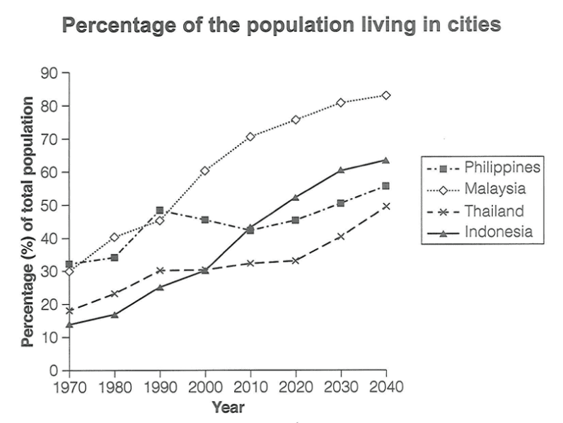
The provided graph illustrates statistical insights related to the population in Asian countries such as the Philippines, Malaysia, Thailand, and Indonesia living in urban settings from 1970 to 2040.
Overall, it is evident that the proportion of people living in urban areas increased in all four targeted Asian countries over the period, and Malaysia continuously had the highest percentage of urban population, whereas Indonesia showed very dramatic growth.
An analytical perspective highlights that, Indonesia started at approximately 12% of the population living in major cities in 1970, while this rose dramatically from 2000 to 2040 and in the end, it reached 60%. Subsequently, Thailand had some fluctuation with upward growth, as it began at 18% and climbed to 30% by the next two decades, meanwhile this remained steady until 2000, thereafter it reached 54%.
In addition to this, the Philippines was relatively stable with small changes over the time frame. In the initial time period, it rose sharply from about 31% to 50%, but later it experienced instability. At the penultimate stage, Malaysia had an unprecedented transformation. In the beginning, 30% of people were living in metropolitan areas, but this trend kept growing and reached the top of the list with more than 80% of the population.

